Mr Thwaite Lowton East,  Neighbourhood Development Forum (LENDF) | Professor Steven Broomhead  Chief Executive  Peter Astley MBE  Assistant Director  Regulation & Public Protection  Reply in writing to:  Development Management  3rd Floor New Town House  Buttermarket Street  Warrington  WA1 2NH  Or e-mail us at:  devcontrol@warrington.gov.uk  2nd March 2015

Dear Sir/Madam

NOTIFICATION OF PLANNING APPLICATION
APPLICATION NUMBER: 2015/25283

Location: | DIGGLE GREEN FARM, WILTON LANE, CULCHETH AND GLAZEBURY, WARRINGTON, WA3 4BD
Proposal: | Full Planning - Proposed importation of organic waste for open windrow composting involving an increase in throughput to a maximum of 75,000 tonnes per annum, an increase in the waste catchment area, reduction in working hours, and reduction in operating hours to those permitted under planning permission 2011/17821
Applicant: | Mr David Broster, A Broster Ltd
Case Officer: | Matthew Woodward - 01925 442075

An application for planning permission as described above has been received by the Council. If you are not the owner of the property, or there are other people living at this address who may have an interest in this proposal please refer them to this letter.

The plans and other details relating to this application are available for inspection on line at www.warrington.gov.uk. Please click on “Comment on a planning application” at the bottom of the home page (guidance on how to access the planning application on-line accompanies this letter). Computers to view applications are available at Contact Warrington, 26 – 30 Horsemarket Street, Warrington, WA1 1XL
between the hours of 9.00–17.00 Monday, Wednesday, Thursday, Friday & 9.00-16.00 on a Tuesday.

If you wish to comment you should do so in writing to Development Control, New Town House, Buttermarket Street, Warrington, WA1 2NH or by email devcontrol@warrington.gov.uk within 21 days of the date of this letter quoting the above reference number and your address. Please note that all correspondence received in connection with a planning application will be available for public inspection via our web site in accordance with the Local Government (Access to Information) Act 1985. Any comments received after the 21 days period may not be taken into consideration when determining the planning application.

All comments will be taken into account. Comments received after the 21 day period may not be taken into account, as part of the determination of the planning application. Comments made relating to a previous application for the same site/address will not be taken into account in respect of the determination of this planning application. It will be necessary for you to make comments referring specifically to this planning application reference in these circumstances.

In most cases applications are considered by officers under powers delegated to the Executive Director of Environment and Regeneration. A leaflet providing guidance in terms of making representations and proceedings for those applications considered by a Planning Committee can be viewed at www.warrington.gov.uk (Please click on “Comment on a planning application” at the bottom of the home page). Please note that if the application goes to Committee, then it may be being filmed.

The Council does not acknowledge receipt of comments received, relating to planning applications or confirm what decisions have been made. However, all comments received and decisions made are posted on the Council’s web site www.warrington.gov.uk (Please click on “Comment on a planning application” at the bottom of the home page).

Please note that proposals may be subject to minor change after original submission, and if you have an interest in an application you are advised to monitor progress during the period of determination as the website is updated.

The majority of applications are decided within 8 weeks (or 13 weeks for major developments or 16 weeks for Environmental Impact Assessment Applications), so it is advisable to check the website after this period if you want to find out whether the application was approved or refused.

If you need to discuss the planning application with the planning case officer please leave a voice mail message and the planning case officer will endeavour to return the telephone call within 24 hours. Alternatively you can email devcontrol@warrington.gov.uk referring to the planning application number and site address and marked for the attention of the planning application case officer.

Yours faithfully
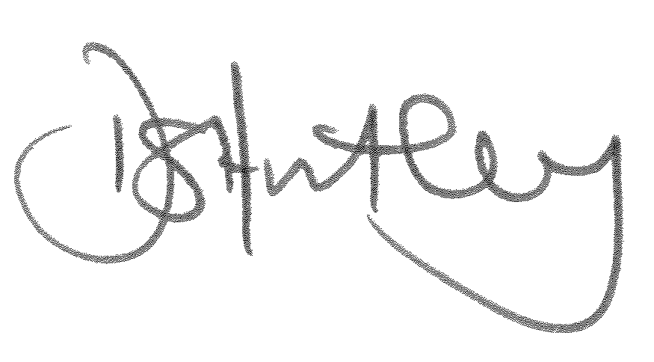
Daniel Hartley MBA MRTPI
Development Manager

How to view Planning Applications online

Please ensure you are using Microsoft Internet Explorer and Adobe Reader – other software may not be fully supported.

Go to www.warrington.gov.uk

On the home page click on Planning applications near the bottom of the page

On the Planning page click on Search for a Planning Application.

On the Planning Application Search Criteria page type the planning application number in the top search box called Planning Reference. Put an * in and then use the last five digits of the application number, for example *12345. Scroll down and click on Search.

On the Planning Application Search Results click on the desired application

The application is split into different sections under planning documents. Double click on your desired section, to view information.

If you require any more information then please contact the Development Control Support Team on 01925 442819

